Sensitive Teeth
Sensitive teeth is due to the exposure of free nerve endings found in the second layer of the tooth, dentin. Dentin becomes exposed when the top layers of the tooth (enamel along the crown of the tooth, and cementum along the root of the tooth) are worn down. Caution must be taken with some sensitivities as they may be due to caries or fractures; please have us check if the symptom is prolonged or very intense.
There are 4 ways expose dentin:
Erosion: Chemical breakdown of tooth structure usually through acidic foods.
Abrasion: The mechanical wearing away of tooth structure usually by brushing too hard.
Abfraction: The defect caused by mechanical flexure of the teeth during clenching and grinding.
Attrition: The mechanical wearing away of the biting surfaces of the teeth during clenching and grinding or even through normal use.
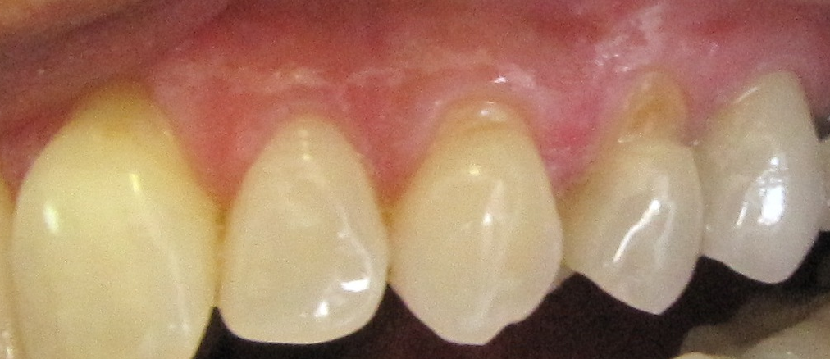

In the mild cases, sensitive teeth may be treated with over-the counter products such as ACT fluoride rinse and/or sensitive toothpastes (e.g. Sensodyne), along with adjustments in brushing, eating, or grinding habits.
In certain moderate cases, if a patient has very sensitive teeth and has only a minor amount of missing tooth structure, then an application of fluoride varnish may be placed. The fluoride varnish would remineralize the area and reduce sensitivity.
In the more severe cases, where the tooth structure has actually been worn away, it may be best treated by repairing the defect with a composite restoration so that further damage to the tooth may be prevented.
